**Basic Anatomy Test**

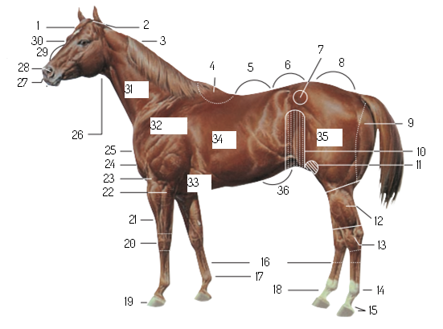

Loin

Back

Crest

Elbow

Neck

Shoulder

Forearm

Barrel

Forehead

Thigh

Muzzle

Flank

Pastern

Ankle

Withers

Cannon

Bridge of Nose

Fetlock

Hock

Poll

Gaskin

Stifle

Croup

Point of Hip

Girth

Face

Nostril

Throat Latch

Point of Shoulder

Chest

Arm

Coronet

Knee

Buttock

Hoof

Abdomen