**Grooming Tools**

**Brushes**

**Curry Comb**

Great for shedding, getting rough spots out, and loosening crusty sweat.

**Slicker Brush**

Great for shedding, getting rough spots out, and the smooth side is good for getting water off horses after bathing.

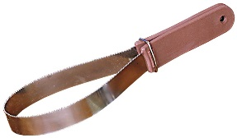 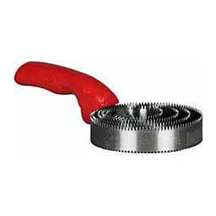 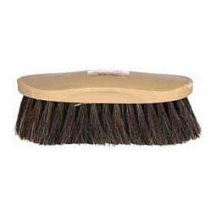

**Bristle Brush**

This is your “all around” body brush. Used for loose hair and debris.

**Hoof Picks**

These are to get mud and rocks out from the hooves to avoid bruising or hurting your horse’s hooves while riding.

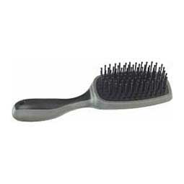 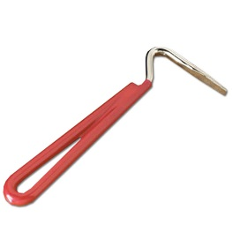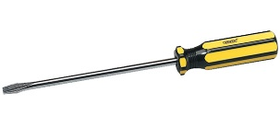

**Mane & Tail Brush**

This is brush is for the long hair on the horse’s neck (mane) and their tail. Work from the bottom to the top to get knots out.