Catching & Leading Your Horse
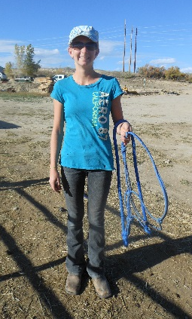
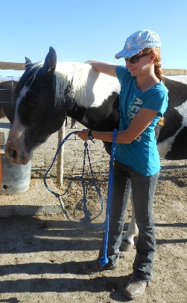
Catching your horse
When going in to catch your horse, it’s best to be prepared before going in the pen. Have your lead rope over your left elbow, and the halter untied with both ends in your left hand. This leaves your right hand available and your tack should never drag on the ground.
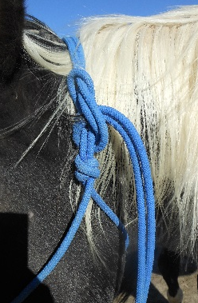
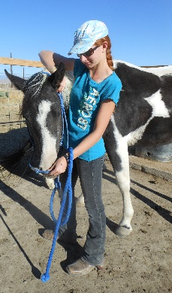
As you approach your horse, you’ll want to end up on their left side. You’ll put your right hand/arm over their neck as your left hand brings the halter up to meet your right hand. Then you’ll take the long “tail” of the halter with your right hand.
Next, bring the halter forward to put the horse’s nose into the opening and tie your halter. The halter should fit snug onto the horse’s face for comfort and control.
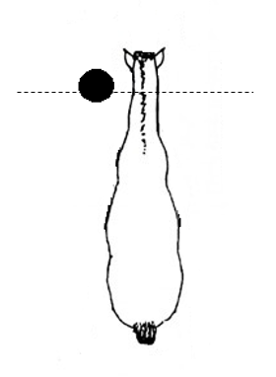
Leading your horse
Rule of thumb: If your horse is on your right, then you’re right.
For best control as you walk your horse, stay at or in front of their throat, as seen in the image.
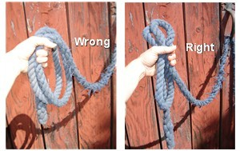
You’ll want your lead rope NOT to drag (your tack should never drag on the ground) and you don’t want the extra to be coiled around your hand. See images below.

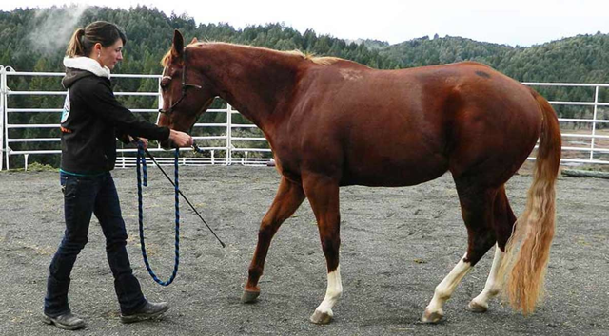

When you want your horse to back up: you’ll turn and face them, pull on the halter straight towards the middle of their chest, and walk towards them.

