**Basic Horse Body Colors**

**Base Colors and American Quarter Horse Colors**

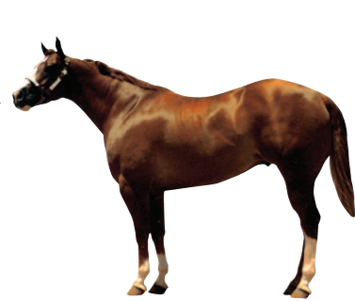

**Sorrel**

The most common appearance of Sorrel is a red body with a red mane and tail, no black points

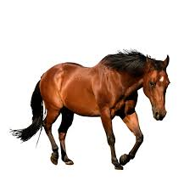

**Bay**

Body is a deep tan, copper-red, brownish red, or a dark red with black points on the mane, tail, lower legs, tips and rims of ears.

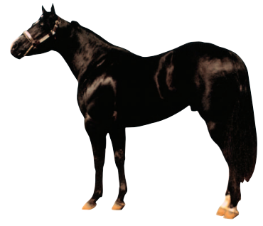

**Black**

Some black horses stay “true” black year round where others may fade with the sun but are still genetically black. Know that many horses are not “born black” but after they shed their first coat the black will stay.

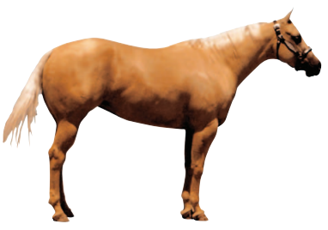

**Palomino**

The body of a Palomino will appear pale, yellow, golden, light tan, or sometimes a musty chocolate color. The mail and tail will be almost white, flaxen, or blonde.

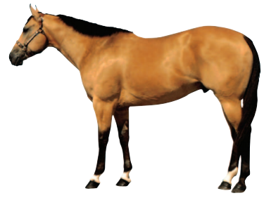

**Buckskin**

Body color is very light, yellowish, golden, light tan, or even a deep tan. The Buckskin will have black points on the mane, tail, lower legs, and tips of the ears. Sometimes the mane and tail will appear “frosted” with white hairs.

**Dun**

Very similar to the Buckskin as body color is very light, yellowish, golden, light tan, or even a deep tan. The Dun also will have black points on the mane, tail, lower legs, and tips of the ears. A Dun will have the some or all of the follow characteristics; dorsal stripe, zebra stripes on the legs, and striping over the withers. (Note: there are also “Red Duns” that instead of black points they appear as red points.)

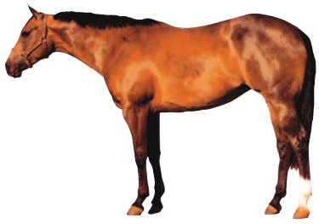 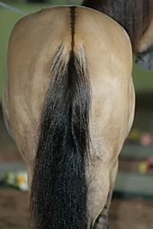

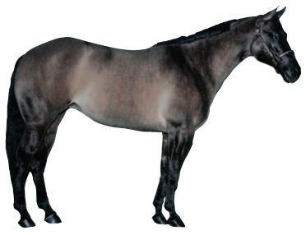

**Grullo**

Pronounced ‘grew yo or grew ya’ will have a gray, silvery, smoky, or some lighter or darker version of these colors as the body. Some have a ‘warmer’ hue to their coat that is close to the Dun and they should have some or all of the following characteristics as well; black points, dorsal stripe, zebra stripes on the legs, stripes over the withers, and a black or very dark brown head.

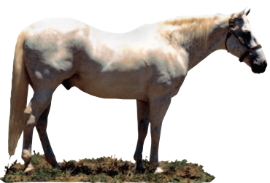

**Gray**

Gray horses can and typically will start out as ANY color and will shed and/or fade into the gray. They will turn Gray starting around the muzzle, ears, flank, or ends of the tail. On Gray horses the head will shed/fade to match the body color.

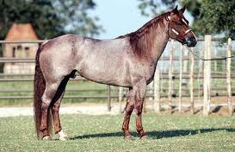

**Red Roan**

Body color is tan, light red, to dark red (with no black points) and white hairs mixed in. Typically the head and legs show only the base color and the mane and tail are ‘frosted’ with the white Roan gene.

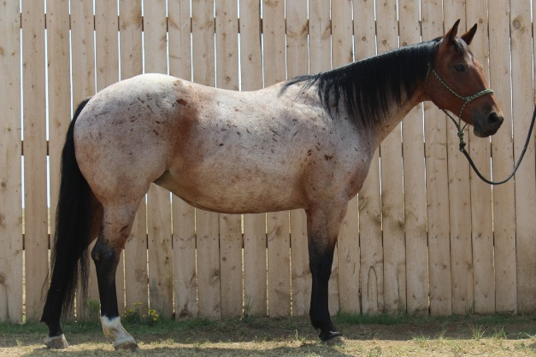

**Bay Roan**

Body base color is the same as the Bay (Light red, copper red or dark red with black points of the mane, tail, and legs) with the added Roan gene that mixes white hairs with the body. Typically leaving the head and lower legs showing just the base color.

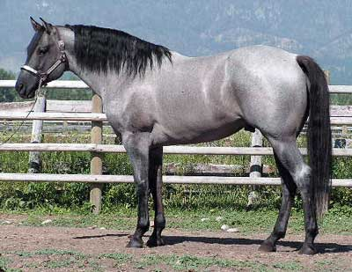

**Blue Roan**

Body base color is the same as the Black with the added Roan gene that mixes white hairs with the body. Typically leaving the head, lower legs, mane, and tail showing the black base color.

**American Paint Horse Patterns**

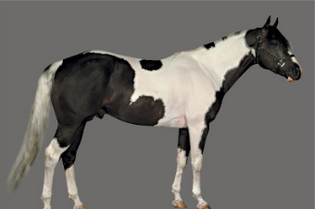

**Tobiano**

Dark colors typically over both flanks, generally white legs below the hocks or knees, distinct round/oval spots, and the tail is often 2 different colors.

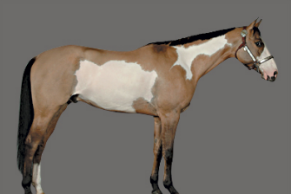 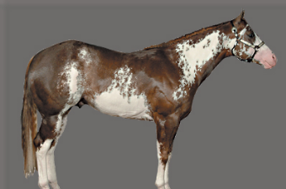

**Overo**

Typically the white does not cross over the back, generally at least one leg is dark, white pattern is scattered and splashy, tail is typically one color, and the head usually has a distinctive markings often as bald, apron, or bonnet face.

**Tovero**

This is a cross between a Tobiano and an Overo. Typically the dark color is around the ears, sometimes extending over the forehead and/or eyes, and around the mouth. One or both eyes are blue, and the flank spot(s) range in size that are often accompanied by smaller spots that extend forward across the barrel and up over the loin.

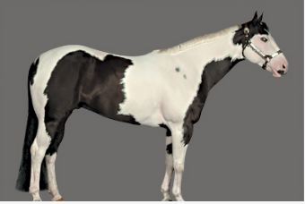

**Appaloosa Horse Patterns**

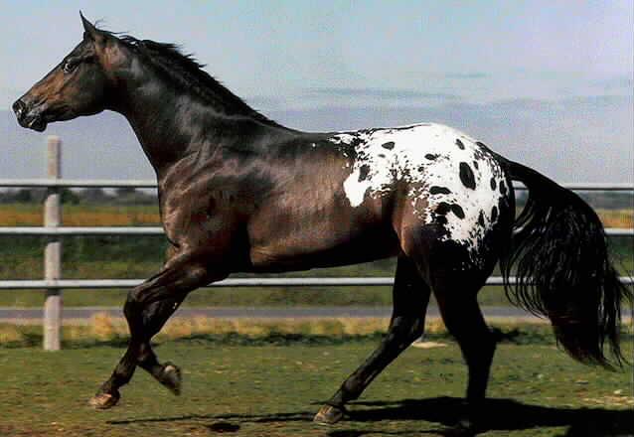 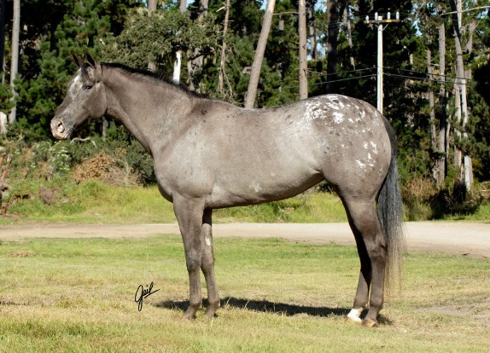

**Blanket Appaloosa**

The above picture to the left shows the typical Appaloosa Blanket pattern that has the white over the top with spots within it. On the right shows a Blanket Roan Appaloosa.

**‘**

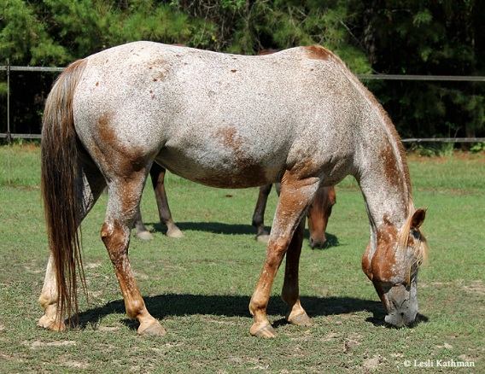 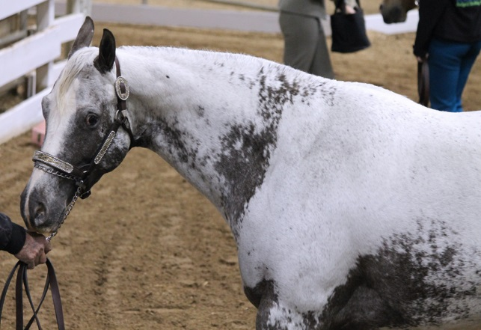

**Roan Appaloosa**

The Roan Appaloosa pattern has all the characteristics required for an Appaloosa (mottled or parti-colored skin, white sclera, and striped hooves) but the pattern consists of lighter and darker areas without the apparent spots.

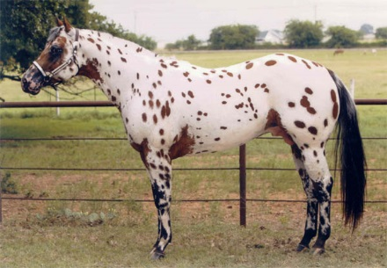 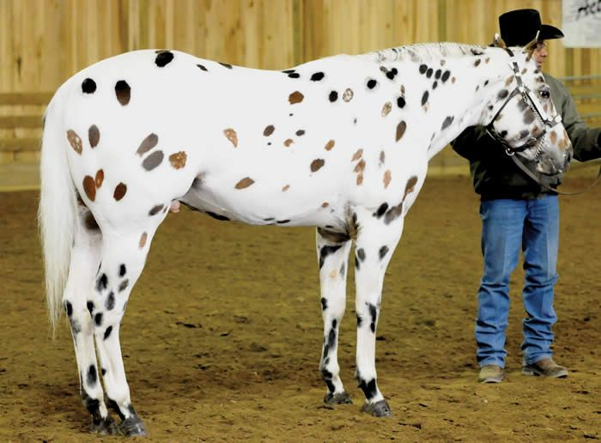

**Leopard Appaloosa**

This is a very recognizable pattern with bigger dark spots all over the body.