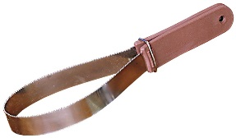
Number_____
Letter ______

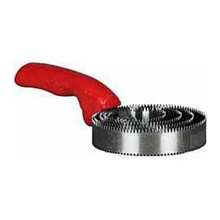
Number_____
Letter ______

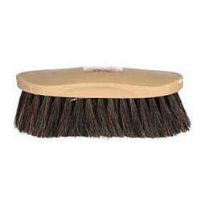
Number_____
Letter ______

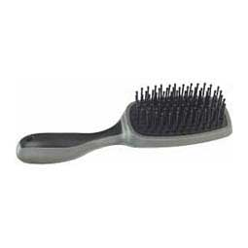
Number_____
Letter ______

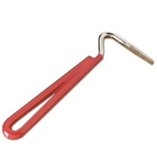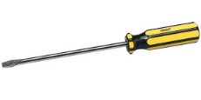
Number_____
Letter ______

1
Hoof Picks

2
Slicker Brush

3
Mane & Tail Brush

4
Curry Comb

5
Bristle Brush

A - This is brush is for the long hair on the horse’s neck (mane) and their tail. Work from the bottom to the top to get knots out.

B - Great for shedding, getting rough spots out, and the smooth side is good for getting water off horses after bathing.

C - These are to get mud and rocks out from the hooves to avoid bruising or hurting your horse’s hooves while riding.

D - This is your “all around” body brush. Used for loose hair and debris.

E - Great for shedding, getting rough spots out, and loosening crusty sweat.

