Identifying Snaffle Bits
Egg Butt Snaffle Dee Ring Snaffle

Full Cheek Snaffle

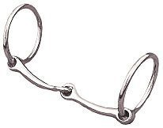 O Ring Snaffle 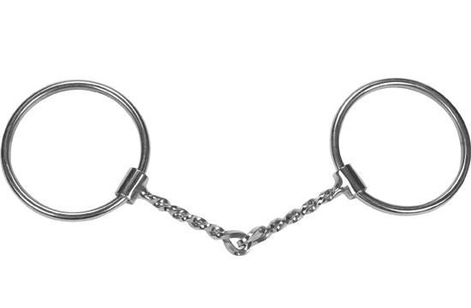 Twisted Wire Snaffle

Identifying Curb Bits

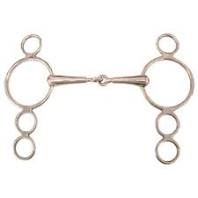 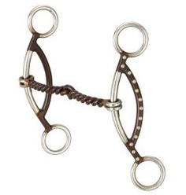 Gag Curb Bit – AKA Gag Bit
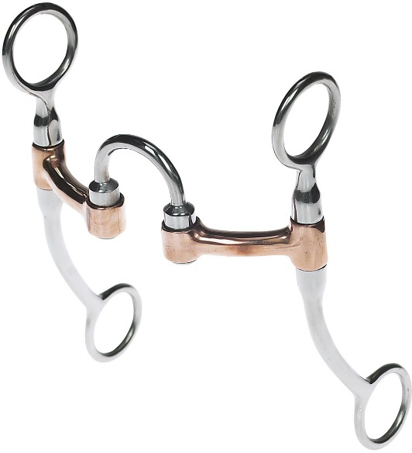 Correction Curb Bit – AKA Correction Bit
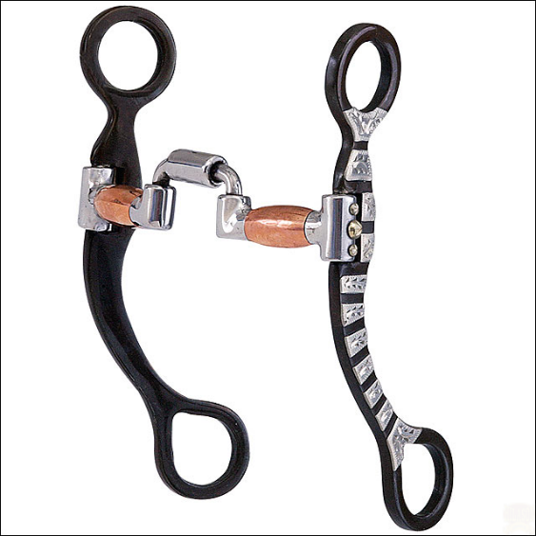 Correction Curb Bit with a Roller – AKA Correction Bit
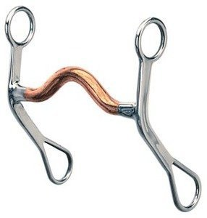 Grazing Curb Bit – AKA Curb Bit
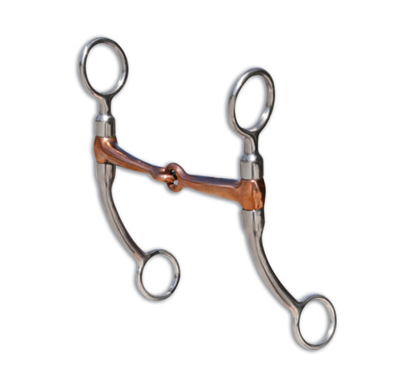Joint Mouthpiece Curb Bit – AKA Tom Thumb
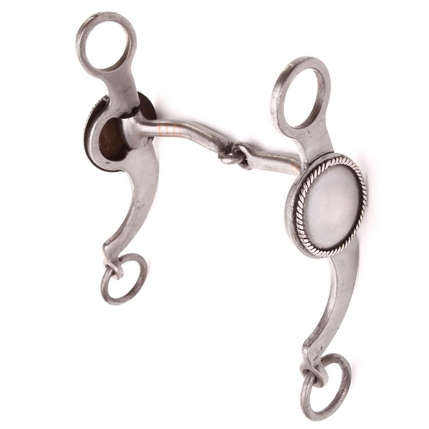 Joint Mouthpiece Curb Bit

