**Leg Markings**

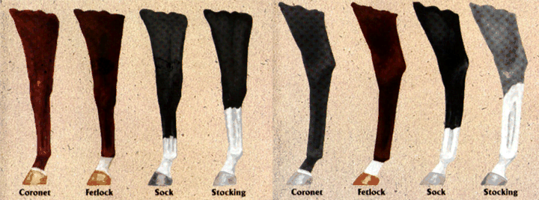

Note:

The Fetlock is often referred to as “Pastern” as well.

The Sock can be made more specific by describing it as a Half Stocking, Half Cannon, or even Three Quarter Stocking.

