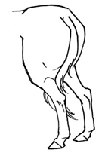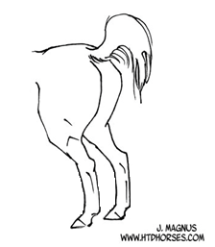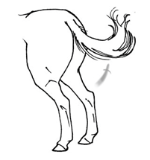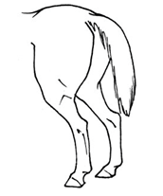

**Swishing**

Also called flicking, this stern movement means the horse is irritated. If it becomes a stern movement, the horse is getting cross/mad.

**Tail Talk – Reading your Horse’s Tail**

Horses are mostly body language communicators, and while plenty of attention is given to the head, let’s not ignore the other end. Here’s a cheat-sheet about what the tail might be telling you.

**Clamped**

Watch out for this one. A clamped tail means the horse is tense. This is saying, “I’m about to kick or bolt. Possibly both.”

**Raised**

This can mean many things. Alertness. Feeling spirited. All of these are symptoms of a raised tail. But mostly is just means your horse hears the “call of nature”

**Relaxed**

While certain breeds may carry their tails higher or lower than others, this is a typical, relaxed tail.